CS23334 – FUNDAMENTALS OF DATA SCIENCE LAB
Experiment No. 2

Title:
Upload and analyze the data set given in CSV format and perform data preprocessing and visualization.

Aim:
To load a sales dataset (sales_data.csv) into a pandas DataFrame, clean and preprocess it (handling missing values), and analyze and visualize the data using bar plots, line plots, pivot tables, and a correlation heatmap.

Software Required:
Python 3, with the libraries pandas, numpy, matplotlib, and seaborn.

Description
The sample dataset sales_data.csv contains daily sales records with the columns Date, Product, Sales, Quantity, and Region. The dataset is loaded into a pandas DataFrame, checked for missing values, cleaned, and then summarized and visualized in multiple ways: a bar chart of total sales by product, a line chart of sales over time, a pivot table of sales by region and product, and a heatmap of the correlation between Sales and Quantity.
Sample Data Input (sales_data.csv)
Date,Product,Sales,Quantity,Region 2023-01-01,Product A,200,4,North 2023-01-02,Product B,150,3,South 2023-01-03,Product A,220,5,North 2023-01-04,Product C,300,6,East 2023-01-05,Product B,180,4,West
... (16 rows in total)

Program / Code
import pandas as pd import numpy as np
import matplotlib.pyplot as plt
# Load the data into a pandas DataFrame file_path = 'C:\\sales_data.csv'
df = pd.read_csv(file_path)
# Display the first few rows of the DataFrame print(df.head())
# Check for missing values print(df.isnull().sum())
# Fill or drop missing values if necessary df['Sales'].fillna(df['Sales'].mean(), inplace=True)

df.dropna(subset=['Product', 'Quantity', 'Region'], inplace=True)
# Summary statistics print(df.describe())
# Group by product and calculate the total sales and quantity product_summary = df.groupby('Product').agg({
'Sales': 'sum',
'Quantity': 'sum'
}).reset_index() print(product_summary)
# Bar plot of total sales by product plt.figure(figsize=(10, 6))
plt.bar(product_summary['Product'], product_summary['Sales']) plt.xlabel('Product')
plt.ylabel('Total Sales') plt.title('Total Sales by Product') plt.show()
# Line plot of sales over time df['Date'] = pd.to_datetime(df['Date'])
sales_over_time = df.groupby('Date').agg({'Sales': 'sum'}).reset_index() plt.figure(figsize=(10, 6))
plt.plot(sales_over_time['Date'], sales_over_time['Sales']) plt.xlabel('Date')
plt.ylabel('Total Sales') plt.title('Sales Over Time') plt.show()
# Pivot table to analyze sales by region and product pivot_table = df.pivot_table(values='Sales', index='Region',
columns='Product', aggfunc=np.sum, fill_value=0)
print(pivot_table)
# Correlation matrix
correlation_matrix = df[['Sales', 'Quantity']].corr() print(correlation_matrix)
# Heatmap of the correlation matrix import seaborn as sns plt.figure(figsize=(8, 6))
sns.heatmap(correlation_matrix, annot=True, cmap='coolwarm') plt.title('Correlation Matrix')
plt.show()

Output

First five rows of the dataset (df.head()):

Date | Product | Sales | Quantity | Region
0 2023-01-01 | Product A | 200 | 4 | North
1 2023-01-02 | Product B | 150 | 3 | South
2 2023-01-03 | Product A | 220 | 5 | North

3 2023-01-04 Product C | 300 | 6 | East
4 2023-01-05 Product B | 180 | 4 | West

Missing value check (df.isnull().sum()):
Date 0
Product 0
Sales 0
Quantity 0
Region 0
dtype: int64
- Summary statistics (df.describe()):

count | Sales 16.000000 | Quantity 16.000000
mean | 237.500000 | 5.375000
std | 64.031242 | 1.746425
min | 150.000000 | 3.000000
25% | 187.500000 | 4.000000
50% | 225.000000 | 5.500000
75% | 302.500000 | 7.000000
max | 340.000000 | 8.000000

Product-wise sales and quantity summary:
Product Sales Quantity
- Product A 1350 33
- Product B 850 17
- Product C 1600 36
- Bar plot – Total Sales by Product:
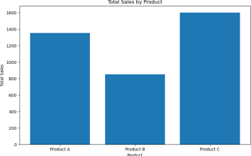

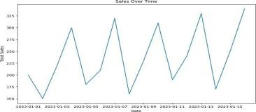
Line plot – Sales Over Time:
- Pivot table – Sales by Region and Product:

Region  East | 0 | 0 | 1600
North | 1350 | 0 | 0
South | 0 | 480 | 0
West | 0 | 370 | 0
8. Correlation matrix:
 | Sales | Quantity
Sales | 1.000000 | 0.944922
Quantity | 0.944922 | 1.000000
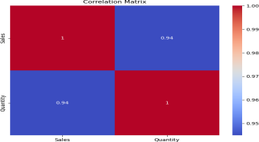
9. Heatmap of the Correlation Matrix:
Product Product A Product B Product C

Result
The given sales dataset was successfully loaded, checked for missing values, cleaned, and preprocessed using pandas. Total sales and quantity were summarized product-wise, and the data was visualized using a bar chart, a line chart, a pivot table, and a correlation heatmap. The correlation matrix shows a strong positive correlation (0.94) between Sales and Quantity, confirming that higher quantities sold are associated with higher sales revenue. Thus, the experiment on data preprocessing and visualization using pandas, matplotlib, and seaborn was executed successfully.

